EcoCrafter Creations Inc. Architecture Design

Ramya Nagabhairu

<https://github.com/Ramya154/Project-Database-Systems>

Windows

**Part 1: Business Description and Supply Chain**

**Business Description:**

For this semester's project, we are launching a groundbreaking business called "EcoCrafter Creations Inc." Our company specializes in crafting and selling eco-friendly, biodegradable, and sustainable home decor and furniture items for the modern environmentally conscious consumer. Our target customers are individuals seeking unique and eco-conscious interior design solutions. EcoCrafter Creations Inc. aims to combine creativity and sustainability to create beautiful and planet-friendly living spaces.

**Company Size and Locations:**

EcoCrafter Creations Inc. is anticipated to operate as a firm of moderate size, employing around 20 individuals that possess expertise in several fields such as craftsmanship, design, and marketing. The main headquarters and workshop are situated in Portland, Oregon, United States. Our strategic objective involves establishing a presence in several places around the United States, including the organization of supplementary seminars in San Francisco and Austin.

**Supply Chain:**

1. Raw Materials: a. Bamboo: We will utilize sustainably sourced bamboo for various furniture items and decor, known for its strength and renewability. b. Recycled Glass: EcoCrafter Creations Inc. will incorporate recycled glass into our products, giving a second life to glass waste. c. Organic Textiles: Natural, organic textiles will be used for upholstery and cushioning, ensuring eco-friendliness.
2. Material Sources: a. Bamboo: We will establish partnerships with bamboo farms in Southeast Asia, where bamboo is abundant and sustainable. b. Recycled Glass: Collaborations with local recycling facilities will provide us with recycled glass materials. c. Organic Textiles: Sourcing organic textiles from certified suppliers focusing on sustainability and environmentally friendly practices.
3. Locations: Our primary office and workshop will be based in Portland, Oregon, where our central operations and product manufacturing occur. We will set up satellite workshops in San Francisco and Austin to facilitate the crafting and distribution of our eco-friendly home decor and furniture across the USA.

**Part 2: Network Architecture Model**

EcoCrafter Creations Inc. envisions a robust network infrastructure to support our operations across multiple locations. Below is a model of our network architecture using Draw.io:

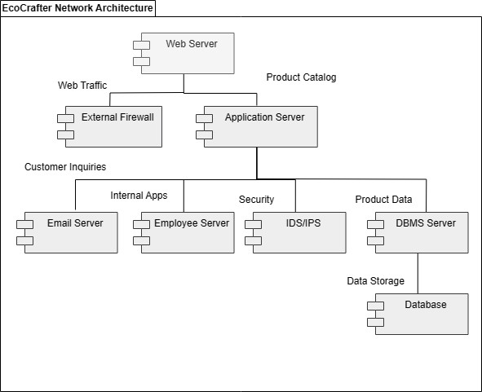

**Components:**

1. **Web Server:** The customer-facing front-end of our company, enabling customers to explore our product catalog and place orders.
2. **External Firewall:** The initial security layer, filtering connections to the web server and securing customer information.
3. **Application Server:** Hosts applications for product catalog management and securely manages online orders.
4. **Email Server:** Manages internal communications and customer inquiries.
5. **Employee Server:** Hosts internal applications and connects to a local area network (LAN) for staff access.
6. **IDS/IPS Server:** An Intrusion Detection and Intrusion Protection System, safeguarding all tiers of the network.
7. **DBMS Server:** Stores and manages product inventory, customer data, and order history securely.
8. **Database:** Contains information on product details, customer profiles, and order records, protected by the IDS/IPS layer.

Our network architecture is designed to ensure the security and efficiency of our operations, allowing us to provide unique, eco-friendly home decor and furniture items to environmentally conscious consumers across the USA.